TALES OF TINMOUTH

December 2025 Tinmouth
Vol. 39 Number 11 Vermont


Editors’ Notes: Peace on Earth, Good Will to All . . .
The deadline for submissions (news, items of interest, get well wishes, ads, etc.) is the 20th of the preceding month. Please email your information to Tales of Tinmouth (tinmouthtales@vermontel.net) or drop it off at the Town Office. Thank you.
Gail Fallar & Pat Psholka

~ Holiday Greetings ~

It’s the Twenty Fifth Annual Community Holiday Card. Please see insert! Thank you to the many folks who so generously donated to the Roy & Anne Wilbur Community Service Fund - this raised over $1,250!!!


You are welcome to join the
Tinmouth Community Church
for a very special
Candlelight Christmas Eve Service on Wednesday, December 24th
5:00 P.M.
All are Welcome!!


~ Library News ~
By Ruth Drachman, Librarian

“A Library is not a luxury, but one of the necessities of life.” - Henry Ward Beecher

Merry Christmas to all. May your Christmas Tree have a new book under it!
And may the world settle down to a boring pace.

We will be open on Thursdays from 2:30 until 4:30. Come and check us out.
Food Drive For
Tinmouth Community
Christmas Food Baskets

Saturday, December 13th
10:00 AM until 12:00 Noon
in the Old Fire House – next to the Town Office
These items will be used for about 20 less fortunate families in town, who really appreciate your generosity. The Mill River High School National Honor Society is providing turkeys/hams as well as milk and eggs. We thank them for their efforts.
Or you can drop items off at the Town Office anytime between now and the 19th.
Non-Perishable Food Items such as peanut butter, jelly/jam, applesauce, pineapple, oatmeal, cereal, flour, sugar, oil, soup, pasta, spaghetti sauce, juice, boxed cake mixes, stuffing, tuna fish, crackers, rice, mac and cheese, beans, vegetables, fruit, cookies, etc.
Household Items such as laundry detergent, dish soap, hand soap, shampoo, facial tissue, toothbrushes, toothpaste, toilet paper, sanitizer, wipes, Clorox.
Pet Food such as canned cat food, canned dog food, small bag dry dog food, small bag dry cat food, dog or cat treats.
Monetary donations to help cover the costs of perish-able items such as meat, milk, juice, eggs, produce, fruit, and bread. Tax-deductible contributions can be made to the Roy and Anne Wilbur Fund (which is under the umbrella of the Tinmouth Community Church), and left at the town office or mailed to 515 North End Rd, Tinmouth, VT 05773.
Also needed are monetary donations to help provide clothes and gifts for kids (books, socks, mittens, toys).
Thank you to the Tinmouth Community Fund for four grants to help with this!!
Thank you for your kind generosity!


Joyous Holidays to All!


Happy December! We’re in that moment between holidays where students and teachers are buzzing with anticipation—waiting for snow, winter sports, family gatherings, and all the excitement this season brings.
We have plenty happening this month. Our annual caroling adventure will take place on the 17th, we’ll celebrate with a festive holiday spirit week, and our student holiday shop will be open for students to purchase gifts for their family members. It’s a joyful, busy time at TMS!
Some students also wanted me to share that we have a new pet in the office. Sadly, Porkchop, our beloved bearded dragon, passed away after an illness. Students immediately expressed that the office didn’t feel the same without an animal friend. After lots of discussion, we decided on hermit crabs as our next pets. Thanks to Chloe Parry, who kindly donated a tank and supplies, I was able to head to Petco and pick out two hermit crabs. They are settling into their new space wonderfully.
One of our students is even writing a paper all about hermit crabs to help the school learn more about our new buddies. If you’re around and curious, feel free to stop in and take a peek!
After a brief hiatus, I’m back on track introducing our fabulous staff! This month we are excited to highlight Amanda Berriault, our school counselor. Amanda recently moved from Massachusetts with her daughter and husband, and we are so grateful to have her as part of our community. She enjoys playing tennis, cheering on her daughter at field hockey, and spending time baking. A fun fact about Amanda: she has a long-term goal of hiking the entire Long Trail from end to end! We look forward to cheering her on in all her adventures—both here at school and out on the trail.
Have a happy and safe December,
Jenn Galusha-Brothers
Principal
Tinmouth Mountain School

“If a child can't learn the way we teach, maybe we should teach the way they learn.” Ignacio Estrada



~ Tinmouth Game Supper
Thank you ~
By Sherry Johnson

Thank you one and all for contributing to another successful Game Supper.
Thank you to everyone who attended. It was heartwarming to see family/friend groups eating together. Also, thank you to all who purchased raffle tickets.
Without this community, we could not host this event. We thank everyone who cooked, provided food, prepped, served, and cleaned up. Without all the community volunteers, our department of 22 could not have put this event on. It was great to see so many young volunteers.
This was, as always, an amazing community supported event and the Tinmouth Volunteer Fire Department's only fundraiser which helps to keep the taxes required to run the Tinmouth Volunteer Fire Department to a minimum.
So once again thank you to everyone who helped in any way.
The Members of the Tinmouth Volunteer Fire Department.

~ TVFD Raffle Winners ~
Winners of the TVFD Raffles
1st Prize – Gun – Sarah Aines
2nd Prize – $200 – Michael Clifford
3rd Prize – 2 Tickets for 2026 Supper – Chris Jones
50-50 Raffle - $127 - Donald Laciberte (Who then bought extra pans of meat and pies for that amount!)
Over 210 folks, plus all the helpers, were fed!

~ Dishes from the Game Supper ~

If you are missing a pie plate or other dishes that you provided food in for the Game Supper, they have been left in the vestibule of the Town Office. Or they may be at the Fire House – stop by the office and we’ll look for them.



~ Winter Plowing ~

As winter is quickly approaching, here’s a reminder about plowing your driveway. It’s actually against state law to plow across the town road. However, if you really, really, absolutely, have to plow across the town road, please make sure that you clean the road really well. Thank you for your cooperation!
~ Community News ~

Get Well Wishes are sent to Chuck Bronk, Beth Eaton, Sally Allen, Alice Hoisington, Carolyn Feury, and Anita Rogers.

Thank you to Kate Start for helping ring the Church Bells at 11:00 on Veteran’s Day!

Welcome to Tinmouth’s newest arrival – Nehemiah Ringger was born on November 13th, son of Hogan and Abigail Ringger, grandson of Chad and Jennifer Virkler. He joins big sister Sarepta.
Congratulations and Best Wishes to All!

Congratulations to newlyweds – Zeb McLellan and Eyliese Jiunta were married this summer on Block Island. May you have many years of happiness!!

~ Town Meeting 2026 ~

Thinking about serving your community? Town Meeting will find voters choosing the following officers:
Moderator - Town - 1 year term
Select Board Member - 3 year term
Town Clerk – 3 year term
Treasurer – 3 year term
Lister - 3 year term
Auditor - 3 year term
Tax Collector (Delinquent) - 1 year term
Petitions will be available after January 5th, five signatures are needed, and have to be returned by 5:00 on January 26th.

~ Tinmouth’s Website ~
Tinmouthvt.gov - There is lots of information about the town on its website, take a few minutes and check it out!!

As daylight hours are getting shorter . . .

~ Please BE Safe – Wear a Safety Vest ~

If you walk, run/jog, bike, or hike, (or even fix fences) along town roads, PLEASE make sure you wear a safety vest so anyone driving along can see you.
Sometimes you might be in the shadow of the trees and no one can see you! Thank you for your cooperation!

~ Minute Taker Needed ~

Ye Olde Select Board Assistant is looking for someone interested in attending Select Board meetings to take notes and then compose minutes. This is a paid position.
Please contact the Town Office at 802-446-2498 or tinmouthtown@vermontel.net for details.
~ Community Thanksgiving Service and Supper ~

This annual event was very well attended, Tinmouth Bell Ringers performed a wonderful song, Ukuleles accompanied a community sing - along, local poet Marshall Squier wrote a new poem (see below), Bob Whitingham’s poem – written for the first Community Thanksgiving Service 23 years ago – was read by his daughter Wendy and great-granddaughters Sadie and Erin, words of gratitude and thanksgiving were shared, as well as the delicious supper that followed!

Thanksgiving Poem 2025
By Marshall Squier

The Halloween wind, cold, screaming and swirling
like dark chocolate pudding inside a blender,
Tried to take over the world, be in charge, but was
stopped by a little lightening bug, tiny and tender.

The world is in a dark place with greed and fear
pretending it is strong,
But that little bug flashed its small light and said,
“I will show you are wrong.”

The darkness must give way to the light as light has
a divine foundation,
Look for the light, walk in the way you look, act in
loves creation.

Darkness needs us to be silent, afraid to turn on our
light,
But be it a beam or a speck, when joined together, will
cause the dark to lose the fight.

So no matter who or where anyone is from, let the light
of Thanksgiving shine bright,
Lighting the path for those whose light is dim, shining
together we can make wrong, right.

The Tales of Tinmouth is on the Tinmouth website (tinmouthvt.gov). Look under “Community Resources”. The online version is in color!!
If you would like to read it online. Or if someone in the house recycles it before you get a chance to read it!
A reminder that no one gets paid for working on Tales, we are all volunteers!! Cost for paper, copying and postage is over $3,000 per year.
Donations to help pay for paper and postage are always greatly appreciated! The cost of paper and postage have increased again this year. Donations have not kept up with expenses. Thank you.

Please Recycle or Pass Along Tales!!

Friends of the Rutland Free Library
December Book Sale
10 Court St., Rutland, VT 802-773-1860
Friday, Dec. 12 (10 - 4) and
Saturday, Dec. 13 (10-2)
Public Always Welcome
Thousands of organized, gently used books, CDs, DVDs and puzzles for all ages.
Always a broad selection of rare and antique books.
All purchases by donation only. Limit of two grocery bags per family. No book dealers.
Proceeds to support library programs and collections and designated library projects. www.rutlandfree.org

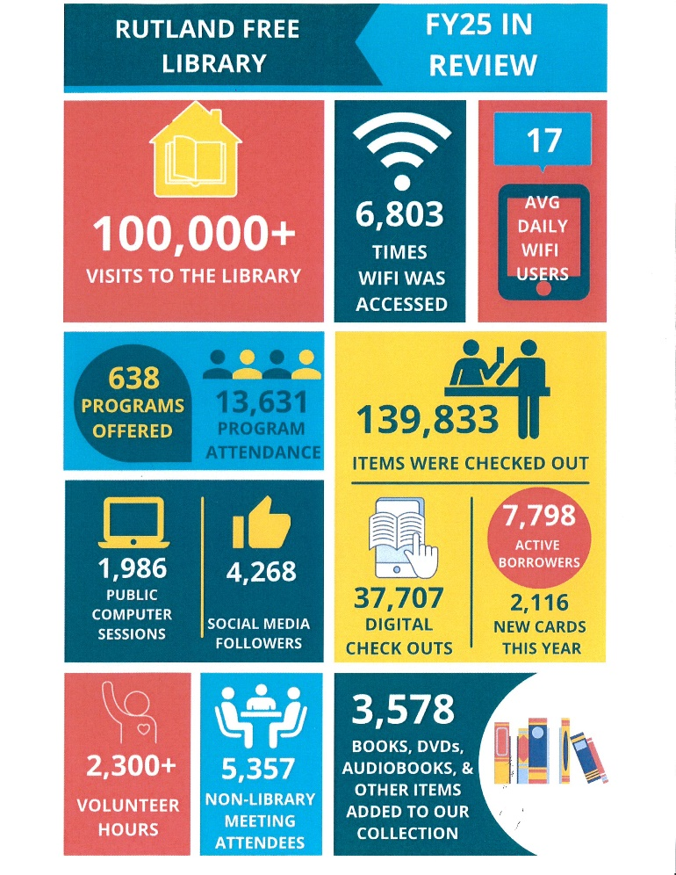

All Tinmouth residents can get a FREE Library card at the Rutland Free Library!

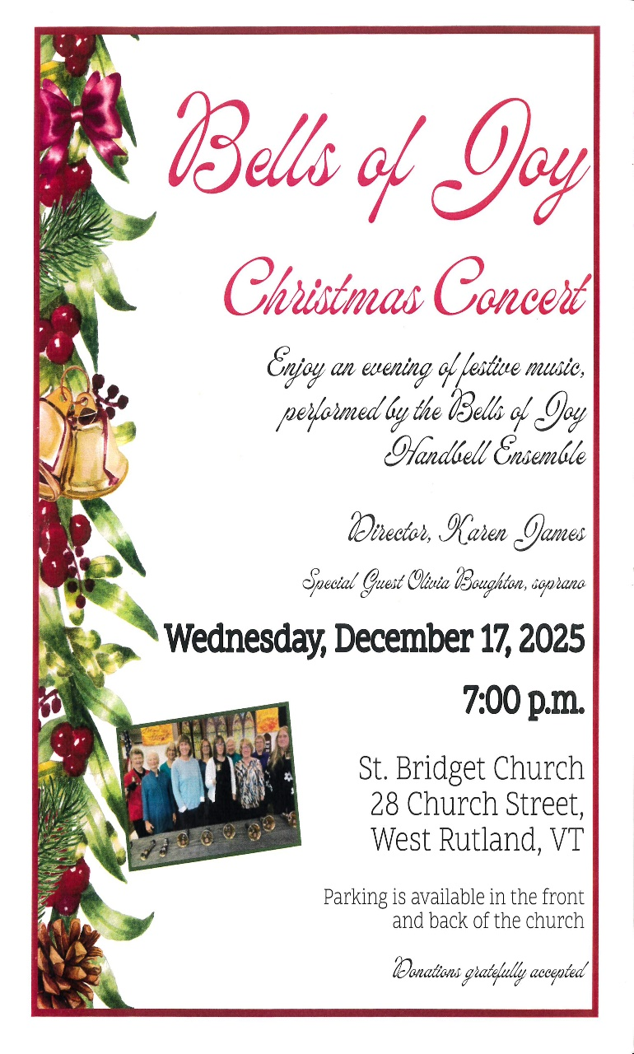
Tinmouth’s Cris Carabeau is one of the ringers!!

* * * * * * *

“The Case of the Missing Tinmouth Apple”

Vermont Public has a program called ‘Brave Little State’. You can Goggle Vermont Public, or Brave Little State and find this episode/podcast. It tells the story of trying to find this long-lost variety of apple, that originated in Tinmouth in the 1800’s.
Very entertaining!! Local apple detectives Marshall and Wheaton Squier think they may have located the last remaining specimen, a very old apple tree in a very old orchard located on the side Tinmouth Mountain.

~ Nature Notes ~

Did you see the full moon shining brightly in the morning on December 2nd? At least until 7:00 AM, just before the sun rose in the east.
An amazing sight!! Moon shine during daylight!!

Stories Told in Tinmouth:
Tinmouth Old Firehouse
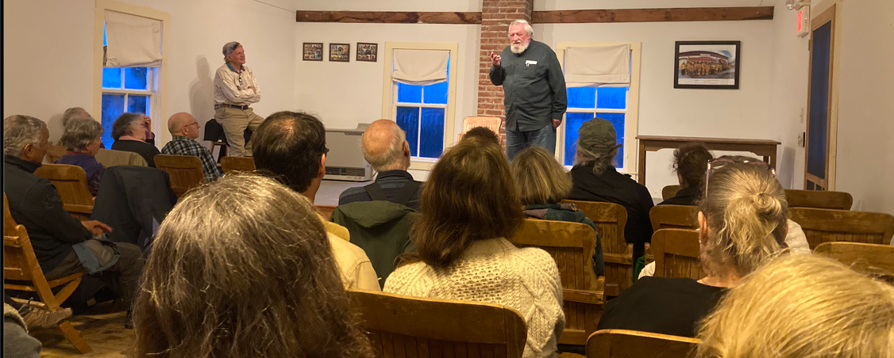

Please join us for an ongoing series of storytelling evenings at the Tinmouth Old Firehouse in beautiful downtown Tinmouth
Weather permitting - the 2nd Friday of each month – 7:00 PM.

December 12 – Kitchen Adventures
(future prompts will be chosen at each event)
January 9
February 13
March 13
April 10

Come share your true 5-minute story with a live audience of kind and supportive listeners, or come to listen and enjoy!

Use the prompt to inspire you, or share a story based on your own inspiration. Stories about Tinmouth are always welcome.

~ Please join us for the fun and refreshments ~

This event is based on our desire to share experiences in stories.
It is based on the STORY SLAM model. Audience members put their name in a basket and storytellers are chosen randomly to tell their true story.

This is a free event sponsored by the Tinmouth Community Fund.
All are welcome!

Follow us on Facebook: facebook.com/TinmouthOldFirehouseConcerts

Tinmouth Old Firehouse Concerts & Town Events
Questions: 802-881-6775 (call or text)

~ Meeting Highlights ~
Complete minutes are available at the town office.
All highlights are edited by Ye Olde Editor.

Select Board (SB) ~ 11/11/2025 (Regular)
Members present (in-person): Kevin Eaton, Judy Gilmore, and Melody Squier
Others present:
In-person: Eric Buffum – Road Commissioner, Ann Lundquist, Michael Fallar, Marshall Squier, and Gail Fallar-Select Board Assistant (SBA)
Via Zoom: Sherry Johnson, Kim Harbaugh, and Rick Fallar
Minutes of September 2, 2025 and September 29, 2025 – Special Mtgs. with Community Center Board; September 11, 2025 – Regular Meeting; September 23, 2025 – Equipment Fund – Special Mtg.; October 9, 2025 – Regular Meeting; and October 28, 2025-Special Meeting. Board voted to approve all as written.
Highway ~
Eric noted the road crew was ready for the snow; had undercoated the trucks with Fluid Film; and was busy with regular duties – removing fallen trees, filling pot holes, etc.
He advised that the tractor needs to go to Salem Farm Supply for leaks and service; the excavator’s bucket has wear bars – he’s trying to decide whether to add or change.
Board asked him to document all oil changes in Equipment logs.
Eric noted that the brush burn pile was really getting scattered, was a concern, he pushed some of it back into place.
Salt Shed location – Eric advised he was able to move the 3 biggest rocks and would be able to flatten the area in a day (if the ground doesn’t freeze), to give everyone a better idea of where a salt shed might fit. Board okayed that activity.
FY27 Draft Highway Budget – After brief discussion, advised SBA to use a 3% salary increase for now (same as last year).
Salt Shed – Added to agenda for the December meeting.
Financial ~
Treasurer advised that the end of year reports were still being worked on and reviewed.
Gail advised that Kate Start had been hired as a part time bookkeeper/office assistant.
Bills and Orders ~ Board reviewed warrants. Board voted to approve and accept. Payroll warrants #15, 16, 17, 18, and 19 and accounts payable warrants #9, 10, 11,12, and 13.
FY27 Draft General Budget – Need to remember to add money for planning, composting, a future re-appraisal, and the child care payroll tax.

Old Business ~
Members discussed complaints regarding out-of-control garbage at 605 Mountain View Road (once again). Many scenarios were discussed, from the road crew cleaning it up with the excavator to hiring a company to do it and then bill the owners and attach a lien if it is not paid; to having the County Sheriff issue tickets for violating the Town’s Solid Waste Ordinance. Various Select Boards and Health Officers have attempted to resolve the issue – only to have the garbage accumulate again. All agreed that it is a serious public health issue that needs to be addressed – the SB has several questions for the Vermont Department of Health and an attorney. The Select Board and the Health Officer constitute the local Board of Health, which can issue clean-up orders. Will discuss further in December.
Since Jeff Warfle stepped down as Health Officer in April due to his becoming the Ludlow Polic Chief, the office has been vacant. State law stipulates that the Select Board Chair becomes the Health Officer if the SB does not recommend someone for the Vermont Health Department to appoint. As no one has stepped forward, despite numerous attempts at recruiting, Kevin reluctantly agreed to assume the duties – only until someone else is willing to serve.
Repairs to Community Center/School ~ Board discussed sending a note of appreciation for work done to start needed repairs – it was noted the Doug Fontein had re-built the bridge to the playground (MRUUSD provided the materials and Doug donated his time – thank you); the handicap ramp into the Community Center was re-built with a rail added, and the wall above the kitchen window was repaired – need to look at the list to see what remains and communicate with MRUUSD regarding a time table – and have a meeting in the spring to review. The Community Center floor will be re-coated during the school’s winter break (Dec. 22-Jan 2).
The Board looks forward to completion of repair work and better communications with the MR Facilities Coordinator.
Pavilion Use Guidelines – Still a work in progress, added to December agenda.
Radio Tower Update ~ The SBA advised the tower company objected to the proposed denial of the permit and everyone is waiting for the PUC (Public Utility Commission) to decide how to proceed.
REMC Appointments ~ The Board re-appointed Ray Pratt (EMD) and Matt Patry (EMC) to the Rutland Regional Emergency Management Council.
Minute Taker ~ The Select Board Assistant requested that Board minutes be taken by another – Board agreed by consensus, pay will be at the office assistant’s rate, SBA needs to advertise.

250th Celebration ~ Michael, as Vice Chair of the Tinmouth Historical and Genealogical Society, advised that THGS (which volunteered to head up the 250th celebration for the Town), would like to erect a flag pole on the Town Green with 4 marble plaques with dates of importance (July 4th, etc.). Location is to be determined, would like it to be placed where the school kids will be able to recite the pledge of allegiance, be lighted, and proper flag protocols followed.
Error and Omission ~ Gail, as Chair of the Listers, requested SB permission to correct the Grand List description on the Alma Somers Trust from 240.84 acres to 125.18 due to a subdivision of the property. Calculations were based on the new acreage, but the general description was overlooked. There is no change in value. All agreed by consensus.
Michael invited the SB and others to the December 18th Planning Commission meeting – PC members will be bringing Xmas cookies in honor of the season.

Planning Commission ~ No Meeting in November

Recreation Committee ~ 11/10/25
With thank to Martha Stanley, Sec.

Members present: Robbie Leeds, Martha Stanley, and Via zoom Colleen Balch and Chris Martone
Community Member: Gail Fallar
Gail advised that the Select Board had appointed Chris Martone to the Recreation Committee per this Committee’s request. The Committee welcomed him.
Trail Mapping Update:
Robbie, Doug and Marshall walked trails. Mapping them to go on to All Trails.
* Merrill Spring to Ricketts Road ( connector trail): This is a straight, easily walkable trail. Just under 1 mile.
* Purchase Loop Trail: completed and pending approval to be on All Trails.
* Drachman Trail: A nice loop trail that is mostly marked.
* Discussion needs to happen with the land owners as to how much publicity would be acceptable.
* Walk around the Town Green: a mostly flat walk around the Community green.
* Ridge Trail: The trail is marked and a more challenging hike as it becomes quite steep.
Maps may be added to the Tinmouth website.
Sponsoring Events Update:
Still clarifying with the Town’s insurance company.
Old Business:
Equipment storage possibilities.
Also issues around liability and wavers.
Intro to pickleball and open gym event.
Christmas vacation a possibility if the floor is available ( getting redone) Or February vacation.
The Committee authorized Robbie to determine the dates for these events that work with the availability of the community center during the upcoming school breaks.
Board game night at the community center. Plan at our next meeting.
Perhaps sponsor a cross-country ski/ snowshoe event this winter.
Next meeting : 7:00 PM on January 12, 2026.

I’m Still Looking for Marbles!!
Any size, any color
Thank you to those who dropped some off
at the Town Office!
Please contact Daniel Gervais at 236-1915 or 293-5746

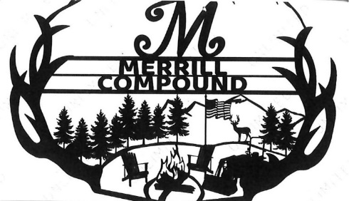
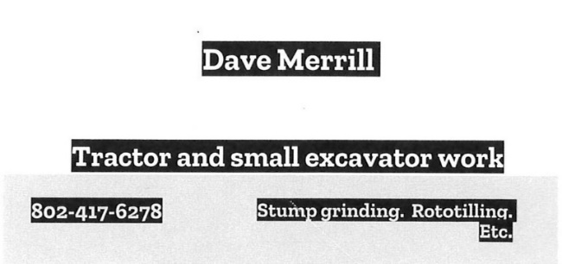




“ Practice Random Acts of Kindness and
Senseless Acts of Beauty”

Tinmouth Road House
and Best Moon Catering

The Tinmouth Roadhouse is open every Saturday for brunch from 8 am until 1 pm.
We have fully cooked and ready to heat and eat frozen meals in our dining room freezer as well.

Please watch Front Porch Forum for details or call Corrie Best at 802-446-9473.
Located at 580 Route 140 – across from the School/Community Center (former Snack Bar).









Keyes Plumbing & Heating, Inc.
~ New Homes ~
~Remodeling ~Radiant Floors ~Heat Pumps
Air Conditioning ~Water Softeners ~Solar Heating
Mini Split A/C
15 East Wells Road
Wells, VT 05774
(802)645-9519
Cell (802)779-4039
Fully Insured
keyes.james@gmail.com





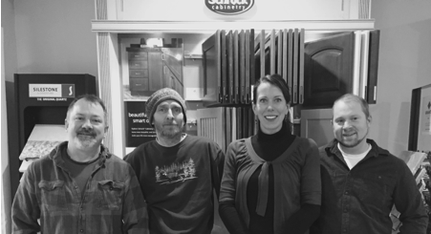


J. ALLEN MAPLE
Pure Maple Products
158 North East Road, Tinmouth, VT
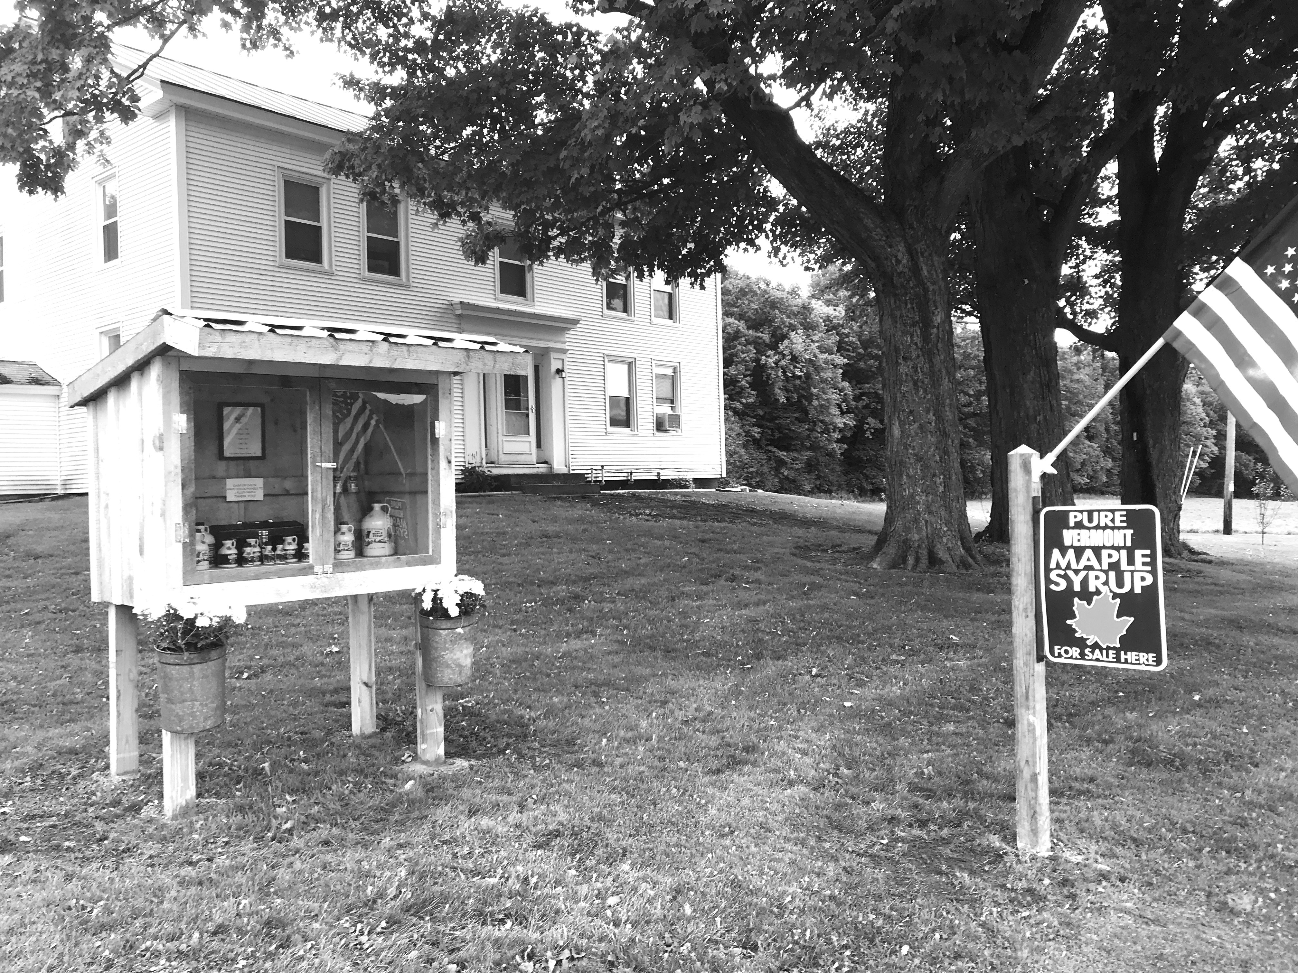
802-353-1857
Stop by our self-serve stand for any of your maple needs. We have Maple syrup sizes range from 100ml to one gallon with prices ranging from $3 to $40.
We also have Maple Cream and Maple Sugar in limited supply. Please contact us with any special orders, we can also accommodate your party/weddings with maple favors!
Great Gift Idea!!

Everyone Is
Welcome in This

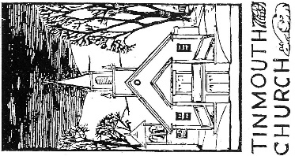
Community of
Worship and Faith

TINMOUTH
COMMUNITY
CHURCH

Sunday Service
9:00 a.m.

Rev. Robert A Noble, III

Open Minds, Open Hearts,
Open Doors

Fire Wood For Sale
Please call Roscoe Jones
802-235-2630







~ December 2025 Calendar of Events ~

Select Board Town Plan Hrg Monday 1st 5:00 Town Office/Virtual
Fire Department Thursday 4th 7:00 Fire House
Select Board Thursday 11th 7:00 Town Office/Virtual
Story Telling Friday 12th 7:00 Old Fire House
Xmas Food Drive Saturday 13th 10:00-12:00 Old Fire House
Hannukah Sunday 14th Sundown
Conservation Commission Monday 15th 7:00 Town Office/Virtual
Planning Commission Thursday 18th 7:00 Town Office/Virtual
Tales of Tinmouth Deadline Saturday 20th Don’t Miss It!
Caroling ?? Watch Front Porch Forum for Details or Contact Marshall Squier

Christmas Eve Service Wednesday 24th 5:00 Community Church
Town Office ~ Closed Thursday 25th Christmas Day

~ January 2026 Calendar of Events ~

Town Office ~ Closed Thursday 1st New Year’s Day Fire Department Thursday 8th 7:00 Fire House
Select Board Thursday 9th 7:00 Town Office & Virtual
Recreation Committee Monday 12th 7:00 Town Office/Virtual
Planning Commission Thursday 17th 7:00 Town Office & Virtual
Tales of Tinmouth Deadline Saturday 20th Don’t Miss It!

Transfer Station hours are Wednesday 4:00 – 7:00 pm & Saturday 8:00 am – noon.
Please note the Transfer Station will be OPEN both Christmas Eve and New’s Year’s Eve – regular
Wednesday hours 4:00 – 7:00 – per the Attendants’ Wishes!!

~ Sunday Church Service ~ 9:00 AM All are welcome! ~
~ The Library is open Thursdays 2:30-4:30 PM ~ And the first Saturday of the month, 10 - noon.
Knit/Craft Club ~ Mondays at the Old Fire House ~ 1:00-3:00 All Welcome!

